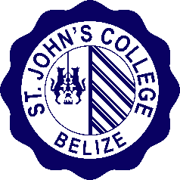
St. John’s College Junior College
PERSONAL DEVELOPMENT RECORD
Name:

Enrollment Status:

Record of Engagement in Co-curricular Activities

Student Life Participation

Club Memberships, Offices Held or other club representations:

Community Service Placement(s) and Hours

Total Community Service Hours:

Awards:

Signed: _________________________
Mrs. Marcia Bouloy, M.Sc., J.P.
Asst. Dean for Student Affairs

Dated: __________________________

Seal/SJCJC Stamp

